Assignment 11

Q1. WAJP to design a method to return double and print it

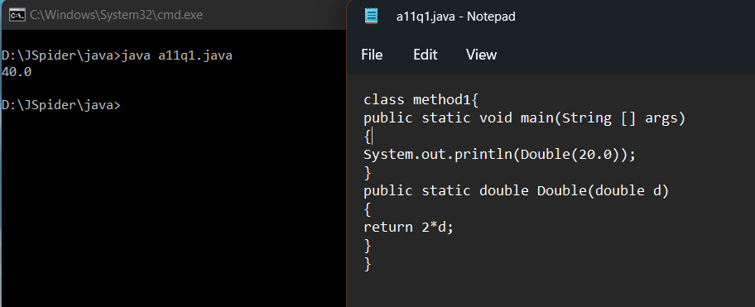

Q2. WAJP to create two methods , one method returns boolean value and other method return string value.

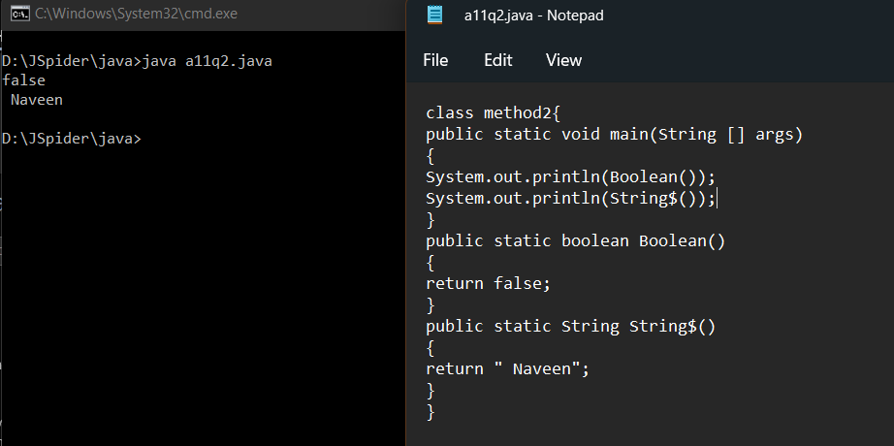

Q3.WAJP to create a method to read all primitive datatype from the user.

